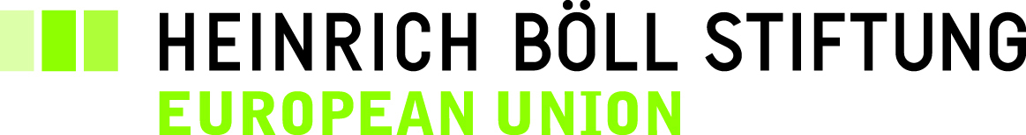

REPLY FORM

BÖLL LUNCH DEBATE
WE ARE EUROPE!
Young Voices from Germany, Greece, Italy and Portugal on the Situation of Youth in Their Home Countries, the European Elections and What They Expect from the European Union

Date Wednesday, 7 May 2014, 12.30 – 14.30
Venue STANHOPE HOTEL
Rue du Commerce 9
B-1000 Brussels

I will participate*:

Name:
Organisation:
Function:
Address:

Tel.:
Fax:

E-mail:

* Because of the restricted number of seats (50) we kindly ask you to register only in case you really intend to attend the meeting. Entrance only with confirmed registration. E-mail registration only.

Heinrich-Böll-Stiftung
European Union
15, rue d’Arlon
B-1050 Brussels

E-mail: marianne.ebertowski@eu.boell.org


"With the support of the Europe for Citizens Programme of the European Union"

